**Assignment #3 Fourier Transform**

P68131509 林均有

1. Implement the Fourier transform and inverse Fourier transform. Apply your coding to the tested images and show the Fourier spectral images (the transformed images in frequency domain).

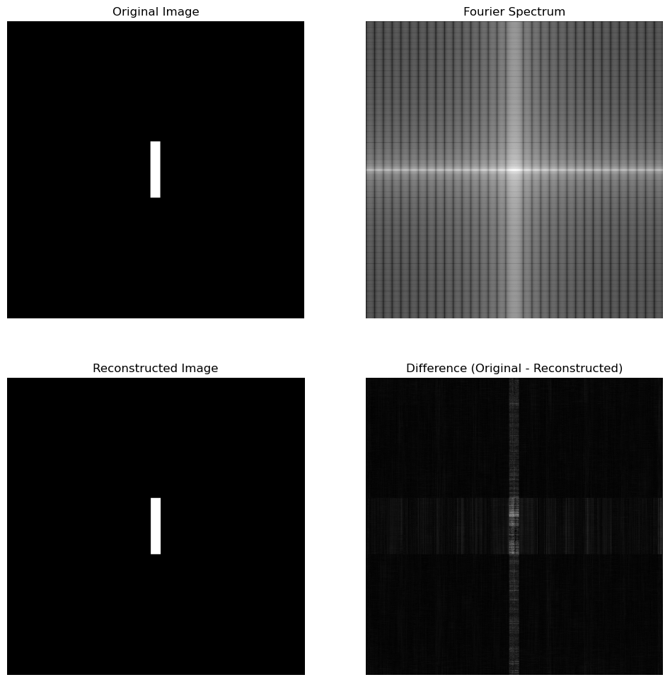

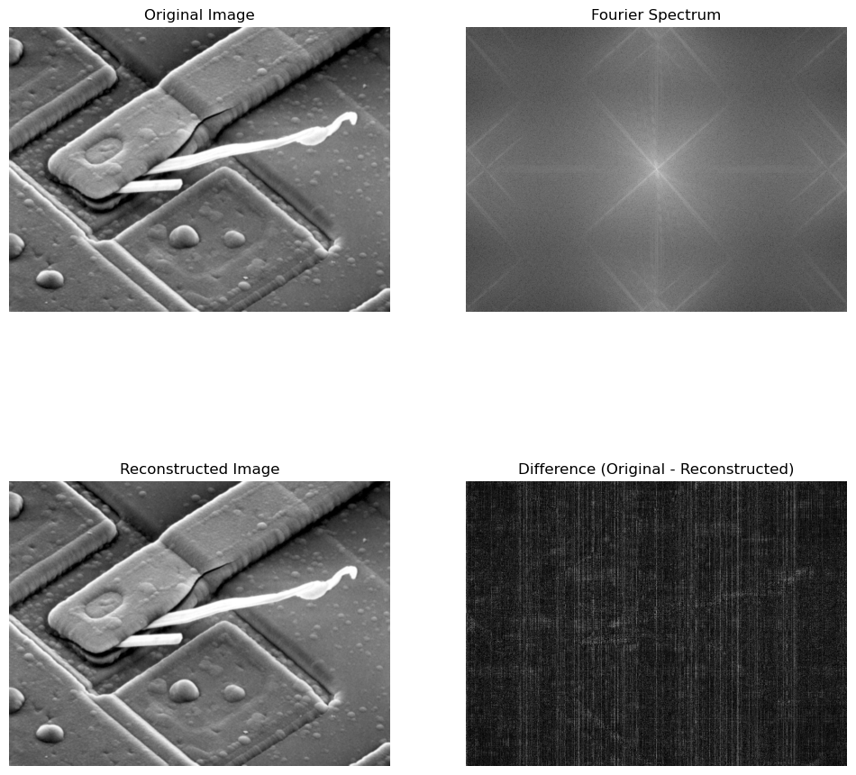

**Fourier Spectrum**: This image represents the frequency domain information obtained from the Fourier transform.

* The Fourier transform converts the image's spatial information into frequencies.
* **Low-frequency components** (smooth or large-scale features) are located near the center of the spectrum, while **high-frequency components** (fine details, edges) are toward the corners.

**Reconstructed Image**: The image was created by applying the inverse Fourier transform on the frequency data.

* This reconstructed image should closely match the original image, representing a return to the spatial domain after processing the frequency information.
* As shown in the Difference image, the reconstructed image closely resembles the original, confirming that the inverse Fourier transform accurately restores the spatial domain from the frequency domain. Ideally, the two images should appear nearly identical; however, slight differences are evident in the figure, which may arise from rounding or numerical precision.

1. Filter the tested images using ideal lowpass and highpass filters with cutoff frequency=5 and 30. Show the filtering results and the kernel functions you used.

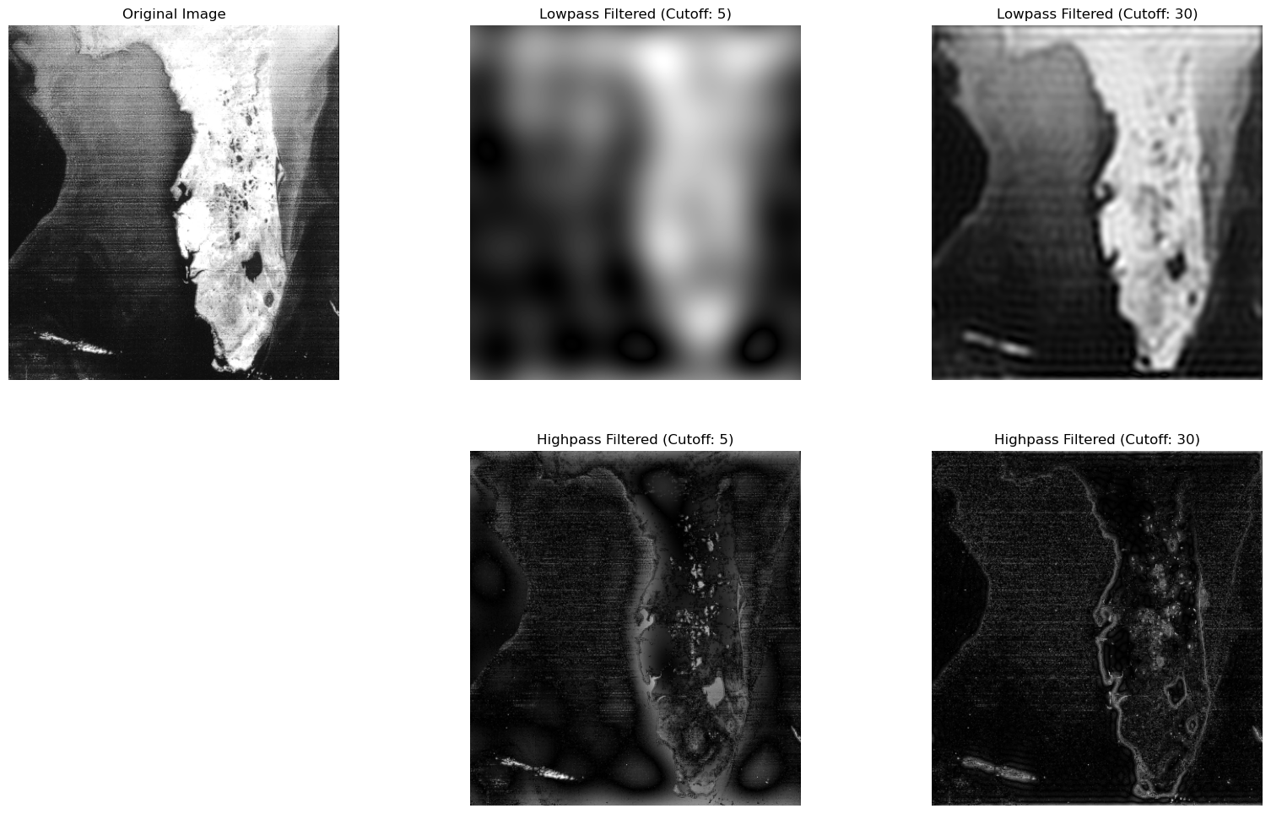

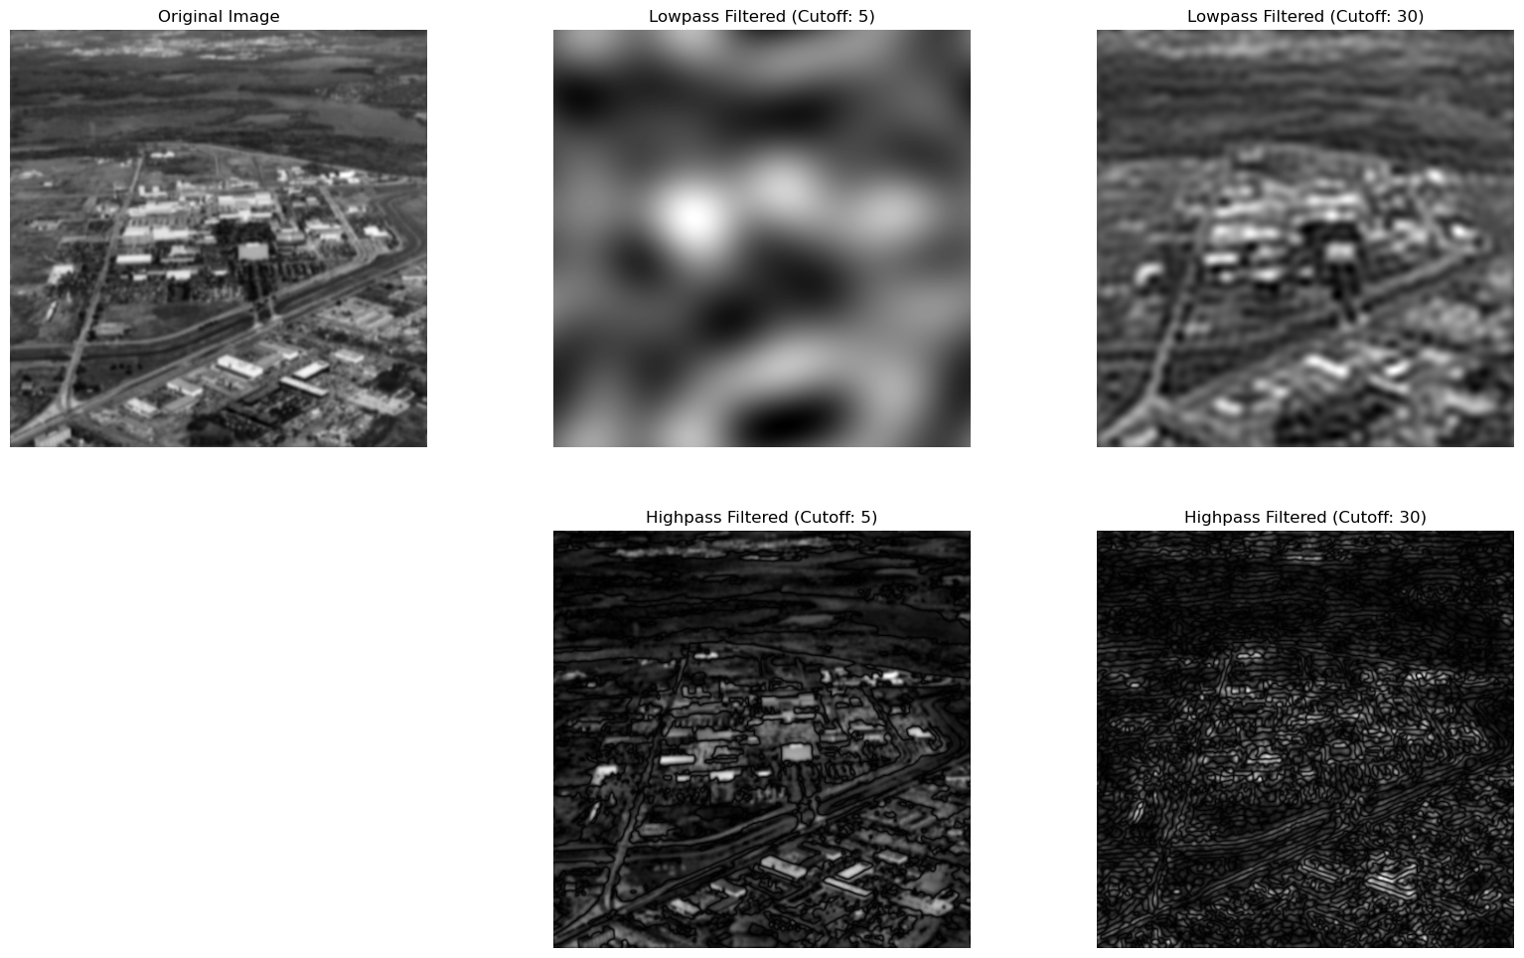

1. Report your results and your observations on these testings
2. **Lowpass Filtering**:
   * With a cutoff frequency 5, the lowpass filter significantly blurred the images, removing most high-frequency details such as fine textures and edges. This strong filtering left a smooth appearance, particularly in the satellite image, where city boundaries and coastline details were lost. This can be useful for tasks requiring denoising or for creating a blurred image background.
   * When the cutoff frequency was increased to 30, the lowpass filter still smoothed the images, but to a lower level. Major structural edges were preserved, and only fine details were softened. This resulted in a cleaner image that retained most of the overall structure but minimized visual noise.
3. **Highpass Filtering**:
   * Applying a highpass filter with a cutoff frequency of 5 highlighted the edges and textures within both images. Fine details and boundaries became more pronounced, allowing prominent features to stand out, such as coastlines in the satellite image and edges in the aerial view.
   * With a cutoff frequency 30, the highpass filter intensified even finer image details. However, the overall appearance became noisier, with many high-frequency components highlighted, giving the images a rough, exaggerated texture that emphasized noise alongside desired details. The highpass filter enhanced edges and textures, making it useful for applications requiring edge detection or feature extraction.